**Assignment – 2**

**Student Name:** Vivek Kumar  **UID:** 21BCS8129

**Branch:** BE-CSE (LEET) **Section/Group:** 809/A

**Semester:** 4th **Date of Performance:** 02/04/2022

**Subject Name:** Computer Network **Subject Code:** 20CSP-256

**1. Aim/Overview of the practical:**

Construct an example to explain the parity check method used for error detection.

**Theories:**

**Parity check:**

Blocks of data from the source are subjected to a check bit or parity bit generator form, where parity of:

1 is added to the block if it contains an odd number of 1’s, and  
0 is added if it contains an even number of 1’s  
This scheme makes the total number of 1’s even, that is why it is called even parity checking.

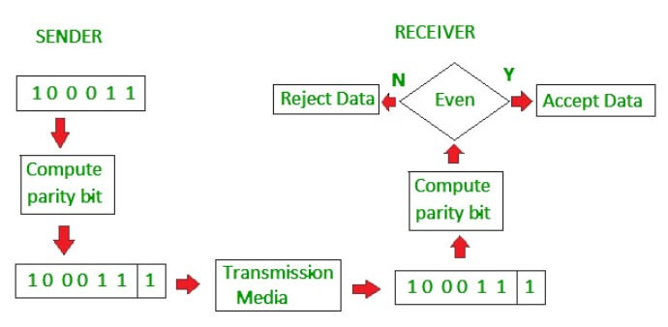

**Evaluation Grid (To be created as per the SOP and Assessment guidelines by the faculty):**

|  |  |  |  |
| --- | --- | --- | --- |
| Sr. No. | Parameters | Marks Obtained | Maximum Marks |
| 1. |  |  |  |
| 2. |  |  |  |
| 3. |  |  |  |
|  |  |  |  |